**Four Year Board question solved:**

**2080**

A machine tool in a manufacturing shop is turning out parts at the rate off one every 5 minutes. As they are finished the parts go on an inspector who takes 10 ± 3 minutes to examine each one and rejects 10% of the parts. Represent the system in GPSS using the concept of facility and run the simulation for 500 parts.

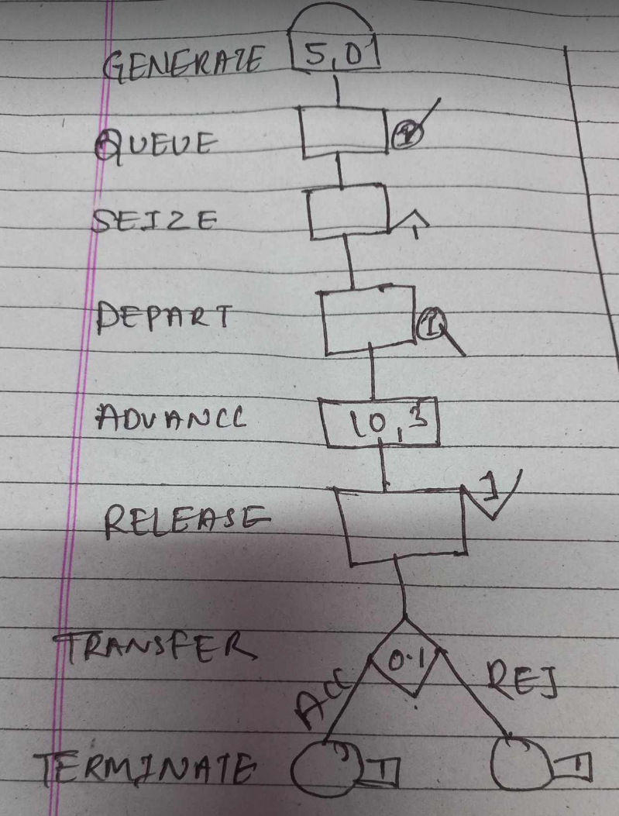

**Code:**

GENERATE 5,0

QUEUE 1

SEIZE 1

DEPART 1

ADVANCE 10,3

RELEASE 1

TRANSFER 0.1,ACC,REJ

ACC TERMINATE 1

REJ TERMINATE 1

START 500

**2079**

Customers arrive at Joey Barbershop one every 15±3 minutes and it takes Joey 18±2 minutes to cut hair of a customer. Create a GPSS model with block diagram for the Barbershop using the concept of facility and run the simulation for 9 hours.

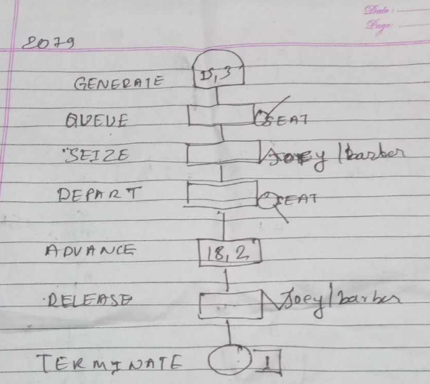

**CODE:**

GENERATE 15,3

QUEUE SEAT

SEIZE JOY

DEPART SEAT

ADVANCE 18,2

RELEASE JOY

TERMINATE 0

TIME GENERATE 540

TERMINATE 1

START 1

**2078**

Workers come to a supply store at the rate of one every 6(+-) 2minute. Their requisitions are processed by one of the two clerks who take 8 (+-) 2 minutes for each requisition. The requisitions are then passed to a single storekeeper who fills them one at a time, taking 6(+-)3 minutes for each. Draw GPSS Block diagram to simulate The above problem for 100 requisitions.

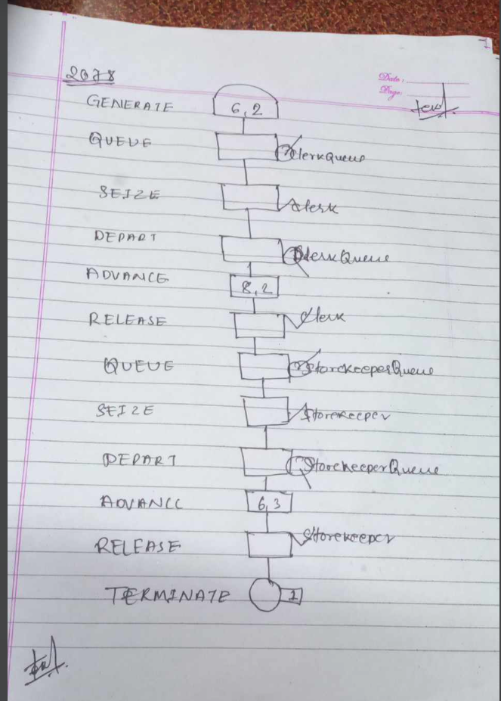

**CODE:**

GENERATE 6,2

QUEUE ClerkQueue

SEIZE Clerk

DEPART ClerkQueue

ADVANCE 8,2

RELEASE Clerk

QUEUE StorekeeperQueue

SEIZE Storekeeper

DEPART StorekeeperQueue

ADVANCE 6,3

RELEASE Storekeeper

TERMINATE 1

START 100

**2076**

Parts are being made at the rate of one every 10 minutes. They are of two types, A and B. And are mixed randomly with about 10% being type B. A separate inspector is assigned to examine each part. Inspection of part A takes 6 ± 2 minutes. Both inspector rejects 10% of parts they inspect. Draw GPSS block diagram to simulate the above problem for 100 parts.

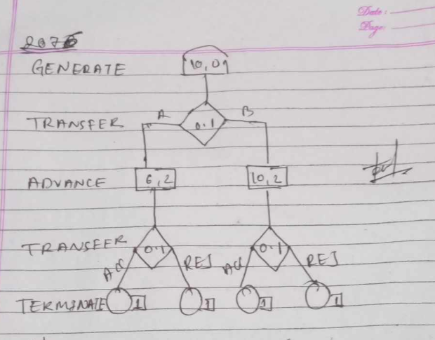

**CODE:**

GENERATE 10,0

TRANSFER 0.1, A, B

A ADVANCE 6, 2

TRANSFER 0.1, ACC, REJ

ACC TERMINATE 1

REJ TERMINATE 1

B ADVANCE 10, 2

TRANSFER 0.1, ACC2, REJ2

ACC2 TERMINATE 1

REJ2 TERMINATE 1

START 100